NAME :N.Bharath kumar

REG NO :192011444

COURSE :SOFTWARE ENGINEERING

CODE :CSA1001

FACULTY :DR.MARY VALANTINA.G

DATE :28/09/22

LAB MANUAL 11 to 17

**EXPERIMENT :11**

11.Draw a Class diagram for Library Management System using CASE tools.

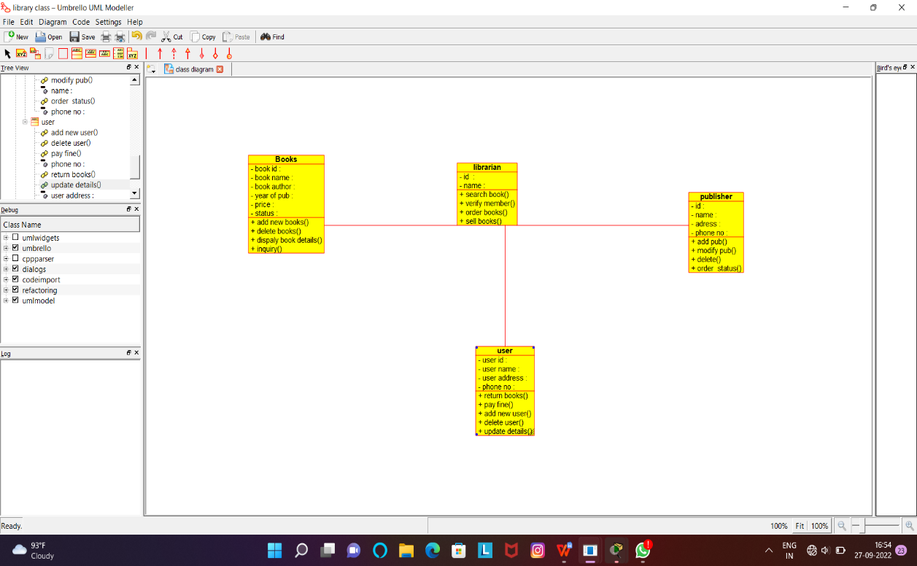

RESULT:Successfully designed this experiment using umbrello tool

**EXPERIMENT:12**

12.Draw a Class diagram for Online Shopping system using CASE tools.

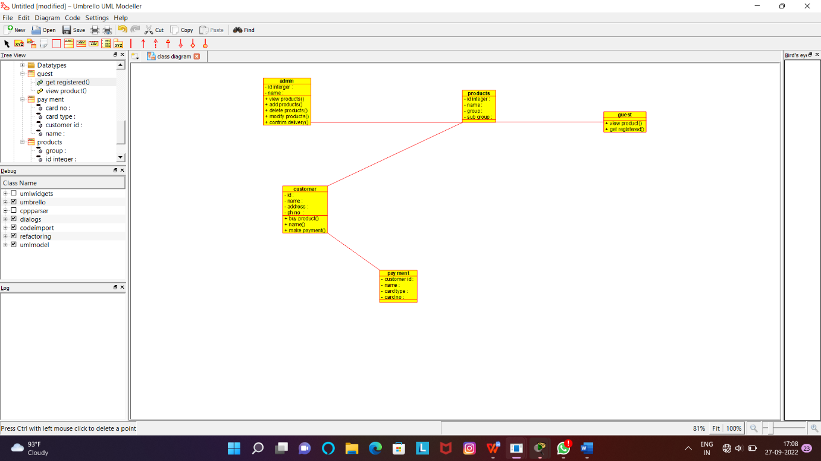

RESULT:Successfully designed this experiment using umbrello tool

**EXPERIMENT:13**

13.Draw a Class diagram for Online Railway Reservation System using CASE tools.

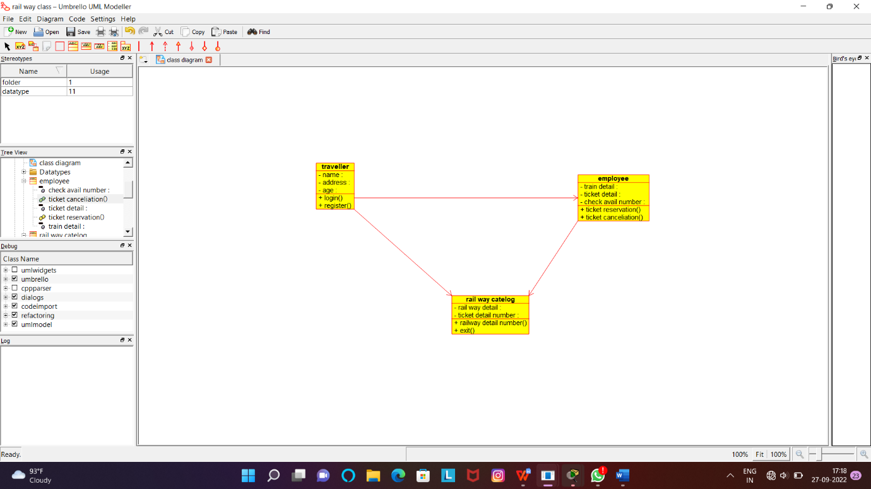

RESULT:Successfully designed this experiment using umbrello tool

**EXPERIMENT:14**

14.Draw a Activity diagram for Online Voting System using CASE tools

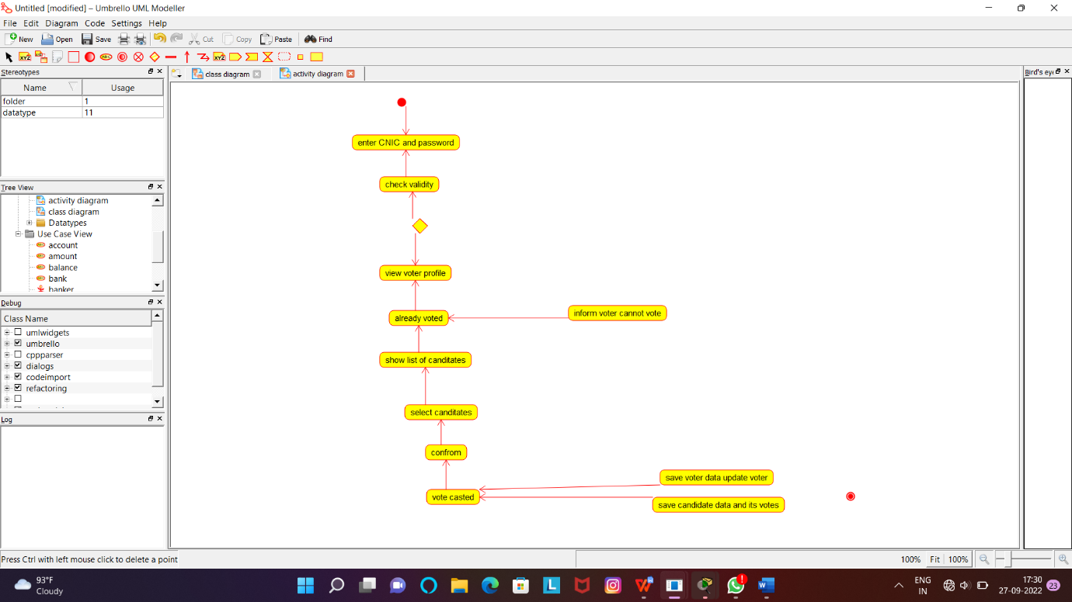

RESULT:Successfully designed this experiment using umbrello tool

**EXPERIMENT:15**

15.Draw a Activity diagram for Library Management System using CASE tools.

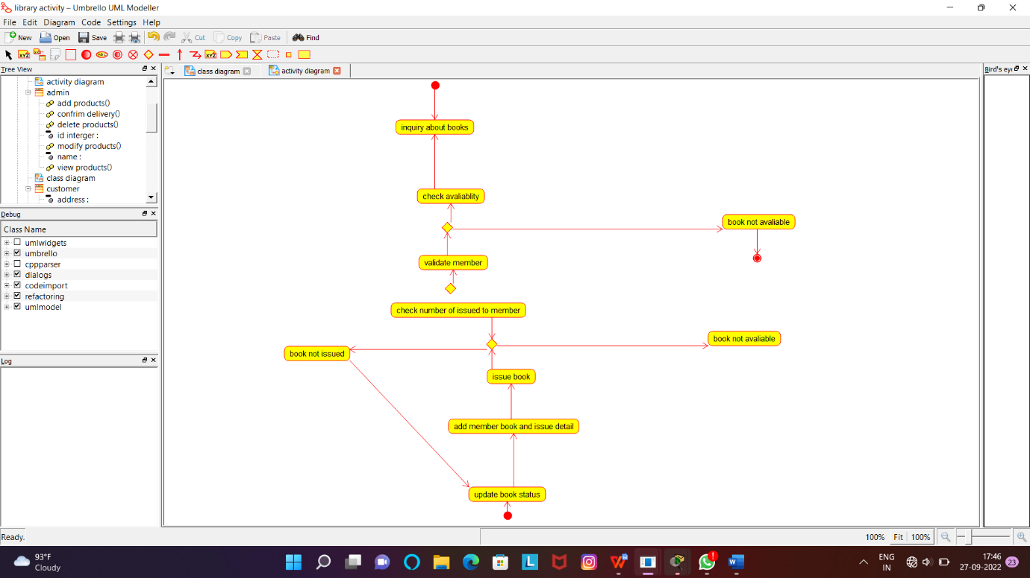

RESULT:Successfully designed this experiment using umbrello tool

**EXPERIMENT:16**

16.Draw a Activity diagram for Online Shopping system using CASE tools.

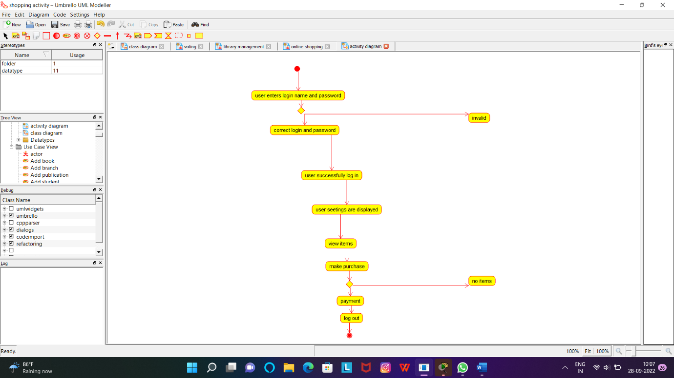

RESULT:Successfully designed this experiment using umbrello tool

**EXPERIMENT:17**

17.Draw a Activity diagram for Online Railway Reservation System using CASE tools.

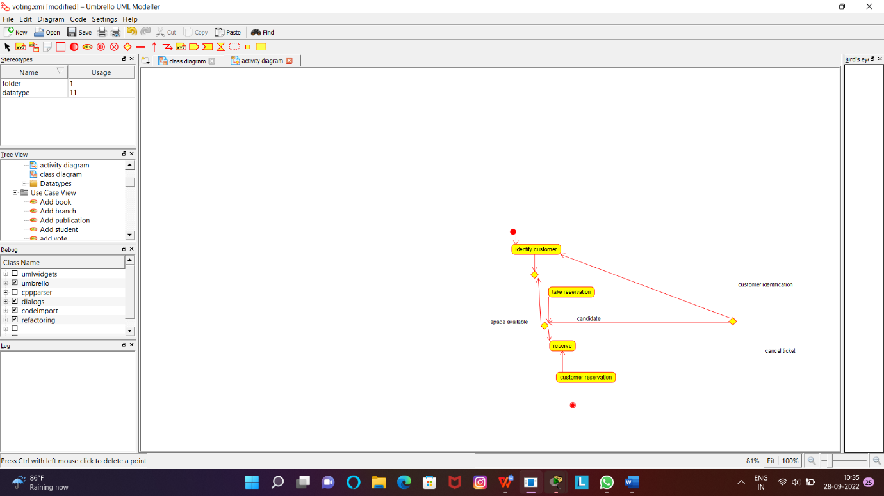

RESULT:Successfully designed this experiment using umbrello tool